Press Release

Jens Delliehausen appointed new Chief Sales Officer (CSO) at K.A. Schmersal GmbH & Co. KG
Experienced sales expert assumes global responsibility for the strategic development of international sales

Wuppertal, March 1, 2026. Effective March 1, 2026, Jens Delliehausen will assume the position of Chief Sales Officer (CSO) at K.A. Schmersal GmbH & Co. KG, thereby taking on global responsibility for sales. In this role, he will strategically develop the international sales organisation and provide new impetus for growth.

Delliehausen will report directly to Managing Partner Philip Schmersal and Managing Director Michael Ambros and will be responsible for global sales at both strategic and operational levels.

He joins the Schmersal Group from automation specialist Lenze. The 54-year-old has extensive leadership experience in sales and specialises in the transformation and further development of sales organisations, successful change management and the sustainable strengthening of market position and sales performance — both nationally and internationally.

His key responsibilities will include managing and continuous optimisation of all global sales activities, the further development of structures and processes, and identification of new markets and growth potential. ‘With Jens Delliehausen, we are gaining an experienced leader who will systematically advance our international sales organisation and provide new impetus for sustainable growth,’ said the Schmersal management.

Caption
Copyright: Schmersal Group
Note: Reprint free of charge – copy requested

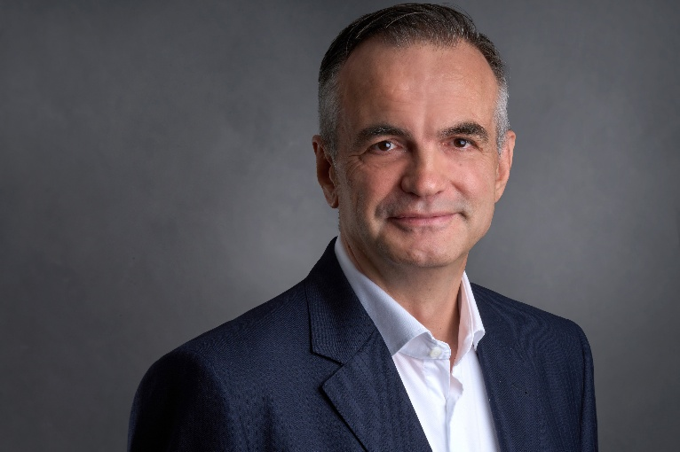
20260301_Delliehausen_01.jpg
Jens Delliehausen, Chief Sales Officer (CSO)
K.A Schmersal GmbH & Co. KG

Print-ready high-resolution image available for download.

Press contact, Headquarters:
Anke Siebold-Laux
Phone: + 49 202 6474-895
asieboldlaux@schmersal.com
K.A. Schmersal GmbH & Co. KG
Möddinghofe 30
42279 Wuppertal
Germany

The Schmersal Group
In the demanding field of machine safety the Schmersal Group is one of the international market and competence leaders. Based on the world's most comprehensive product portfolio of safety switching devices, the group develops safety systems and safety technology solutions for the special requirements of various user industries. Schmersal's solutions include the tec.nicum business division and its comprehensive range of services.
The company was founded in 1945, and is represented by eight manufacturing sites on three continents and with its own companies and sales partners in more than 60 countries. The Schmersal Group employs around 2000 people.

www.schmersal.com
www.tecnicum.com

If you would like to unsubscribe from our press mailing list and no longer receive press releases from Schmersal, simply click on this link:
Further information concerning the data protection policy of K.A. Schmersal GmbH & Co. KG can be found at here.

