PRESS RELEASE

The system family is growing

Individual combination options: The new BDF20 control panel from Schmersal - elegant stand-alone emergency stop or system component of the guard locking system

Wuppertal, 25. November 2025. With the BDF20, Schmersal presents a particularly compact and slim control panel. The new model has two control points and can be optimally integrated into modern door interlock systems thanks to its minimalist design.

Compact, flexible, customisable - Quick installation with M12 connector
The small BDF20 control panel is optionally available in combinations of emergency stop, illuminated pushbutton and indicator light. With its push-button caps in twelve colours, it can be flexibly adapted to the application. The M12 plug connection ensures quick and error-free installation. The control panels with emergency stop can also be connected directly to the Schmersal safety field box. The plug connection on the control panel can be concealed and protected against tampering using the optional MS-BDF40 mounting kit.

Stand-alone solution or system module
The BDF20 can either be used as a stand-alone solution or combined with the AZM40 solenoid interlock and the DHS door handle to form a solenoid interlock system. Thanks to its compact design and flexible installation, the BDF20 is also suitable for door systems with double acknowledgement: a door interlock system with BDF20 or BDF40 as well as AZM40 and DHS is installed on the outside, while a BDF20 with emergency stop and illuminated pushbutton is installed on the inside.

DHS door handle: handle and display in one
In the door interlock system, the DHS door handle combines the function of a robust door handle and an indicator for various machine statuses. The machine statuses are signalled over a large area via the lighting of the DHS in seven different colours, which are individually controlled by the user to display the defined machine status in each case.

Optimised system integration for safety components
The solenoid interlock system is designed for optimum interaction with the AZM40 solenoid interlock and the BDF20 and BDF40 control panels. In addition, the door handle can also be combined with safety sensors from the RSS36 and RSS260 series if no locking function is required.

Download printable photos:

Captions
Copyright: Schmersal Group
Note: Reprint free of charge - please send a voucher copy.

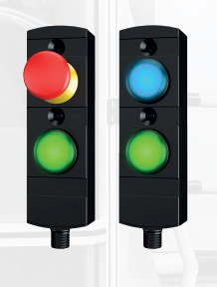

20251125_BDF20_01.jpg
The small BDF20 control panel is optionally available with an emergency stop, illuminated pushbutton or indicator light.

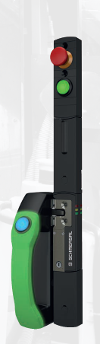

20251125_BDF20_02.jpg
The BDF20 can be installed as a stand-alone system or combined with the AZM40 solenoid interlock and the DHS door handle to create a minimalist door interlock system.

Contact:
Anke Siebold-Laux
Phone: + 49 202 6474-895
asieboldlaux@schmersal.com
K.A. Schmersal GmbH & Co. KG
Möddinghofe 30
42279 Wuppertal

The Schmersal Group
In the demanding field of machine safety the Schmersal Group is one of the international market and competence leaders. Based on the world's most comprehensive product portfolio of safety switching devices, the group develops safety systems and safety technology solutions for the special requirements of various user industries. Schmersal's solutions include the tec.nicum business division and its comprehensive range of services.
The company was founded in 1945, and is represented by eight manufacturing sites on three continents and with its own companies and sales partners in more than 60 countries. The Schmersal Group employs around 2,000 people.

www.schmersal.com
www.tecnicum.com

If you would like to unsubscribe from our press mailing list and no longer receive press releases from Schmersal, simply click on this link:
Further information concerning the data protection policy of K.A. Schmersal GmbH & Co. KG can be found at here

